Enhanced Facial Detection

In this section, I will explain what I’ve done to improve the tilted face detection hit rate. But before that, I will briefly go through how basic OpenCV’s facial detection with haar cascade works.

**First thing first, what is Haar cascade?**

It is an object detection algorithm that makes use of the edge/line detection features proposed by Viola and Jones in their research paper “Rapid Object Detection using a Boosted Cascade of Simple Features” published in 2001. Or to my understanding, it’s an algorithm that, to detect an object, uses a model that consists of features possessed by that object (often those features are selected using a supervised machine learning-based approach) as a classifier.

For example, if we want to detect a face, some of the features that might be selected are eye browns, eyes, nose, etc... But how do we represent those features? Or how can a computer “see” those features?

Say we have a forehead feature. The forehead is above the eyes and is brighter than the eyes. So, we can convert this characteristic into an edge feature (reference the image below).

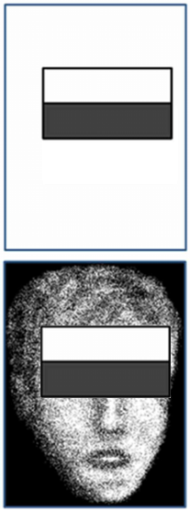  
When scanning for faces in an image, for every potential face, the program will go to the position of the edge/line features and check if the area covered by that edge/line satisfies the feature’ conditions. For this case, we have an edge feature that represents the forehead. If the added-up color value of the white box is brighter than the added-up color value of the black box, that means the program “see” a forehead.

Similarly, given a pair of eyes feature, because in between the eyes, the color is usually lighter than the eyes, the pair can be represented as a line feature.

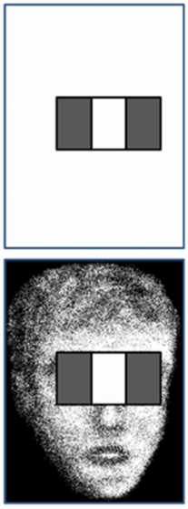

All these haar features are then grouped into an object model to represent the characteristics of that object. The program can just use that object when scanning. If all the haar features are present, then the object is “visible” to the program. If not, then the program “see” nothing.



To summarize, OpenCV obtains a set of Haar features that best describe a face (provided by the user) and use that as a reference when checking for faces. OpenCV go through the image and crop out rectangles (potential faces) in all possible sizes and all possible locations, comparing those cropped out areas with the reference face to check if those satisfy all the facial feature requirements. If any of them do, then that will be considered a detected face.

**Limitation**

Because all the haar features are placed relative to the potential face bounding box. If the box is not aligned with the angle of the face in the image, all the haar features will become misaligned. Therefore, OpenCV would not be able to detect tilted faces.

An example of the forehead features but now it is being used on a horizontal face

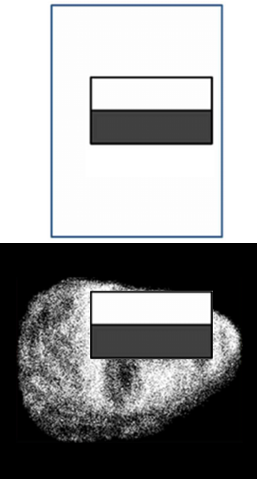

To combat this, my solution is to just simply do the scan in multiple orientations, not just on the vertical image. Once those scans finish, I can just convert the rotated coordinates of the faces found back to the original image’s coordinates axis, check if there is any overlapping face, and remove the duplicates.

One small optimization that I made was to instead of scanning for faces directly, the program scanned for eyes (which takes half the time compared to scanning for faces). Then it checks if the eyes have a similar size and the distance between the two is appropriate (not too close/too far). For every pair of eyes it finds, it will crop out the potential face area around that pair of eyes, then do facial detection on that small area only. If a face is found, I can use the relative locations of the eyes to further investigate which one is the left eye, which one is the right eye.

-My rotation function in action

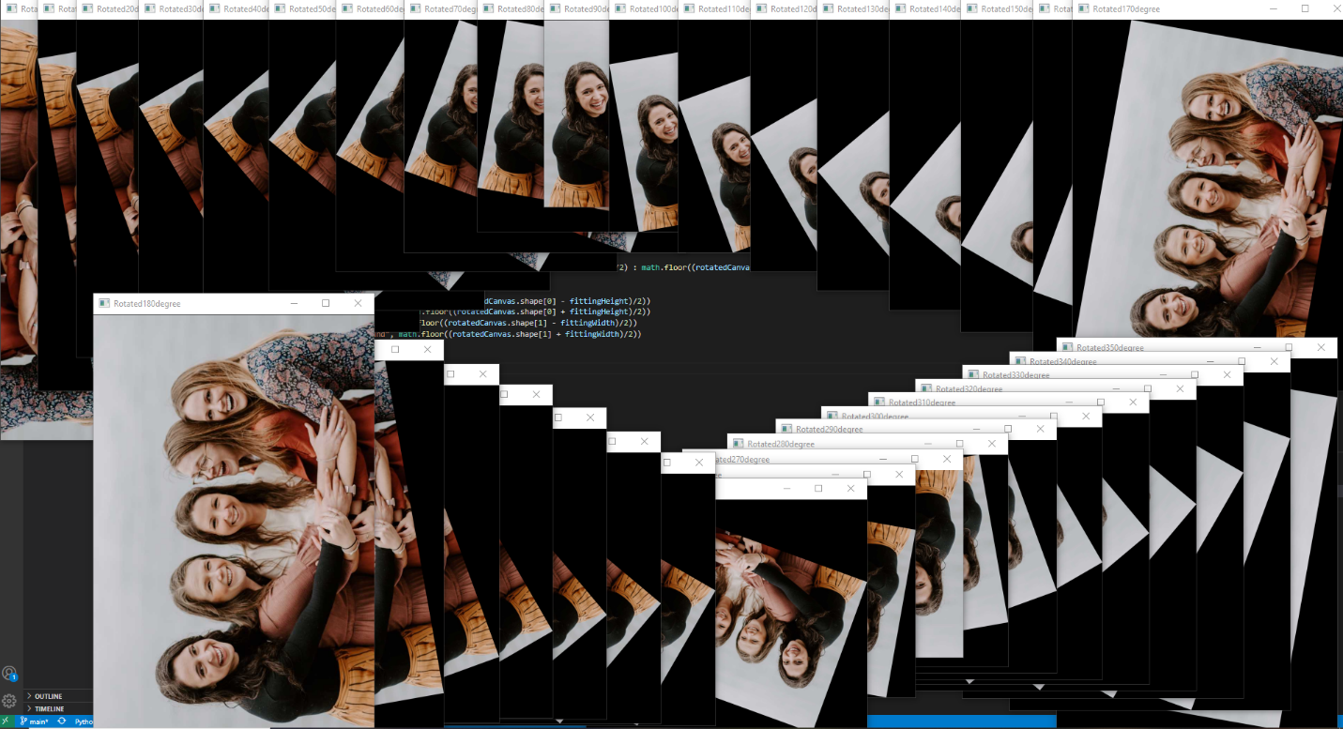

-A glimpse into what my program sees for each step

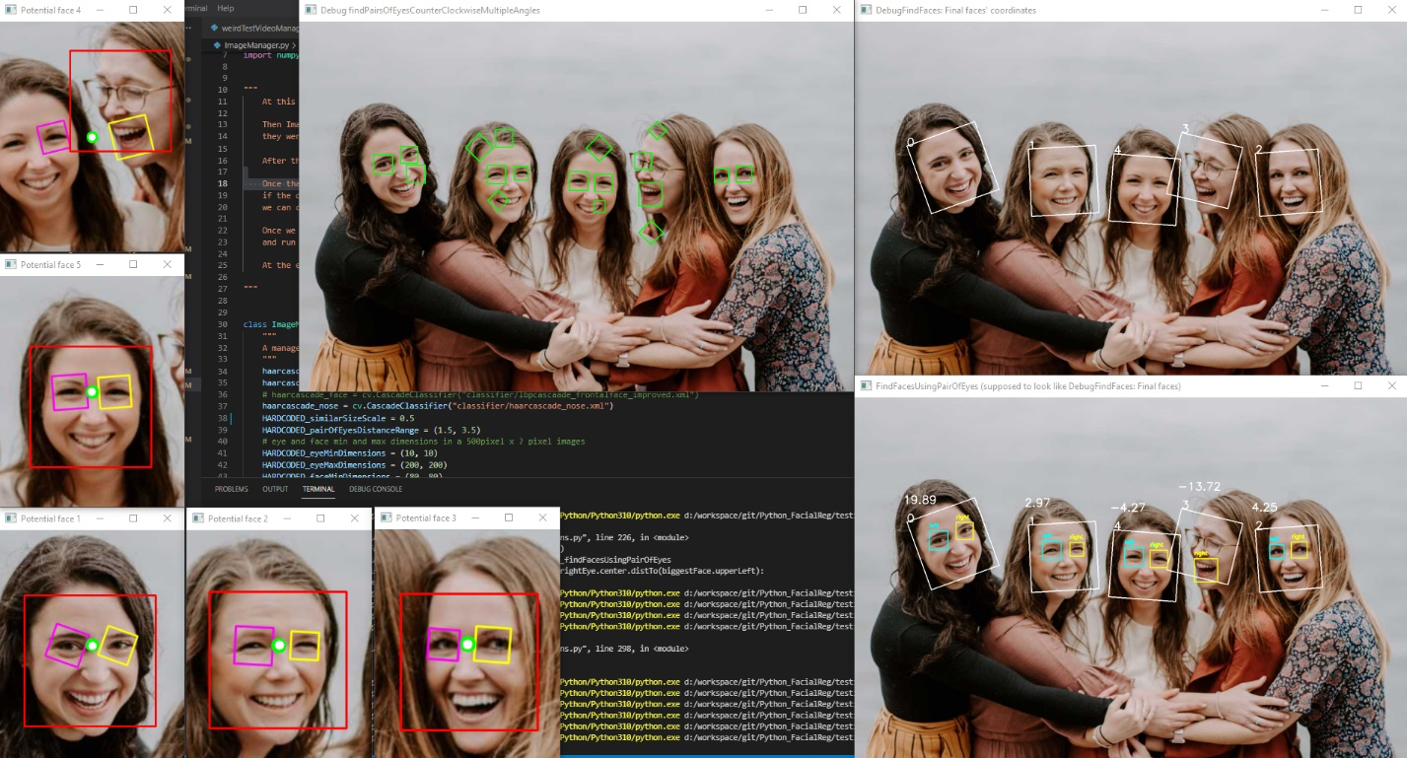

My solution works well enough for detecting faces in images. But it doesn’t return the result fast enough for real-time detection (3 times slower than the traditional method). In this section, I will go through what I did to improve my algorithm performance, while still maintaining the same high level of tilted face detection accuracy.

“Vanilla method” “My method”



**Optimization 1: Reduce frame-time**

So how can I reduce the detection time for each frame in my algorithm? Well, I noticed something. I don’t have to run my facial recognition implementation on every frame, do I? If I only run it on every third frame on a 30fps video, then the face has 3 * 1000ms / 30 = 100ms to move out of the previously detected face area.

The human average head width is around 7 inches in width or 18 cm. To move one’s head out of one’s head’s previous position by 18 cm in 100ms, one must move at 18cm/100ms or 1.8m/s or 71 inches/s, which is incredibly fast. So, I can safely assume that after 3 frames, there is a very high chance that the face that was detected previously would stay around the area that it was before.

Alright, with that assumption in mind, I can created a ‘macroThread’ that runs my implementation of facial detection. And whenever that thread is done (around 2-4 frames), it updates the faces’ coordinates onto a ‘foundFaces’ array.

For each new incoming frame, the program will simply render the frame and use the faces’ information in foundFaces to render the bounding boxes. My program will also check if the macroThread is running. If it is not, then the program will start up the macroThread again and have that execute on the current frame.



The video is now playing at the correct speed. Great! However, the face’s bounding box kinda lags by a little bit.

**Optimization 2: Accuracy**

The bounding boxes are only relatively close to the actual faces’ positions. To increase accuracy, what I can do is, instead of rendering the boxes based on the foundFaces array, use the array as guidelines to narrow down where the faces could be to perform OpenCV’s facial detection (which is very fast).

For every new incoming frame, the program launches a ‘microThread’ that does the following:

For every faceArea in foundFaces:

Rotate the frame by the angle of the face so that the face is now vertical-ish (This helps with OpenCV facial recognition)

Crop out the area of the face in faceArea, but also increase the width and height of that search area by 50% (to account for the face moving out of its previous position)

Perform facial detection on that cropped-out area. Update the face coordinates in faceArea

Perform eye detection on that cropped-out area. Check which one is the left eye/right eye based on the distance of them to the face’s upper left corner. Update the eyes in faceArea

Calculate the angles between the eyes. Use that angle to update the face’s angle in faceArea (face’s new angle = face’s previous angle + eyes’ angle). This helps keep track of the face’s orientation.

Render faceArea’s bounding box onto the frame

Render the frame



By combining Haar Cascade fast facial detection with my slow but thorough implementation, the final result is an accurate tilted facial detection with good enough performance to run in real-time.

Comparisions



Please keep in mind that I oversimplified a lot of what I actually did to keep these sections short. There were multiple edges cases that I had to account for, many more weren’t mentioned things that I had to make to help speed up the development process, and a lot of experimentings with different technologies/frames work I had to do to be able to finish this project (or these two projects).